**Outline VS Border**

CSS has the following outline properties:

* outline-style
* outline-color
* outline-width
* outline-offset

**CSS Outline Style:-**

**Ex.**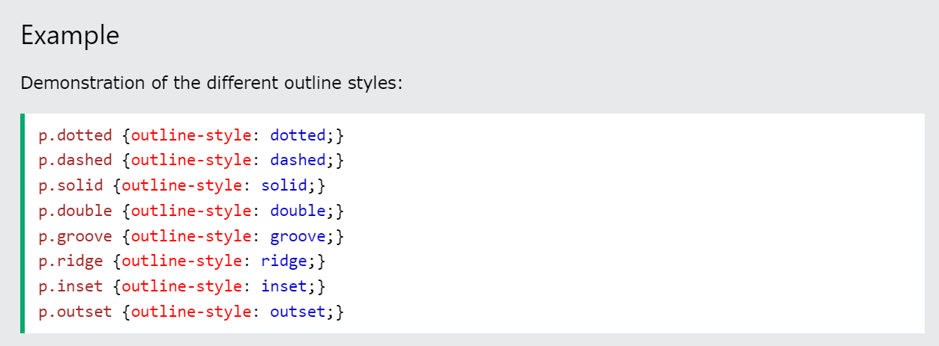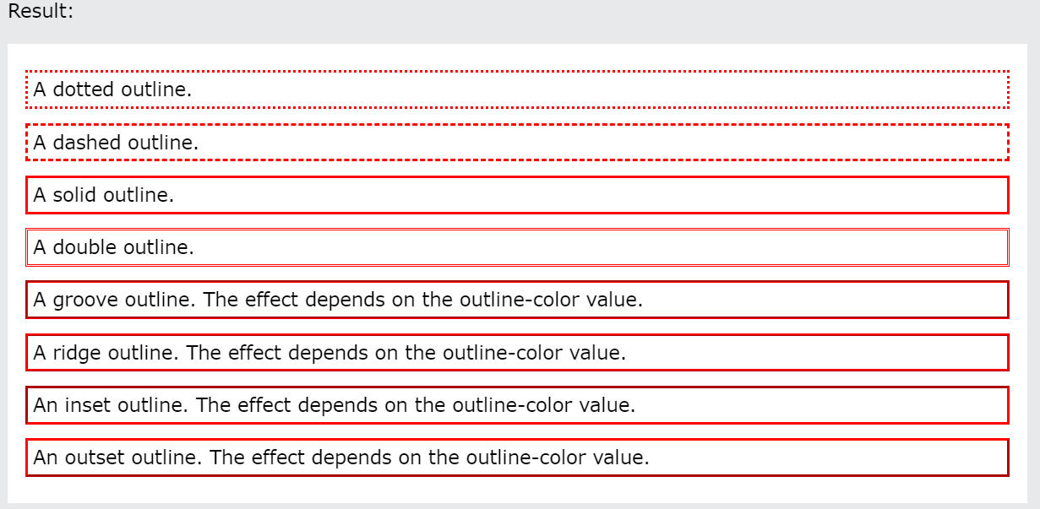

**CSS Outline - Shorthand property.**

**Ex.**

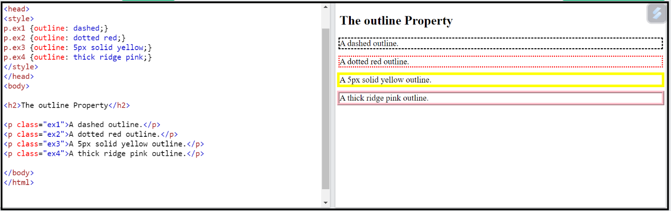

**Outline-offset Property.**

**Ex.**

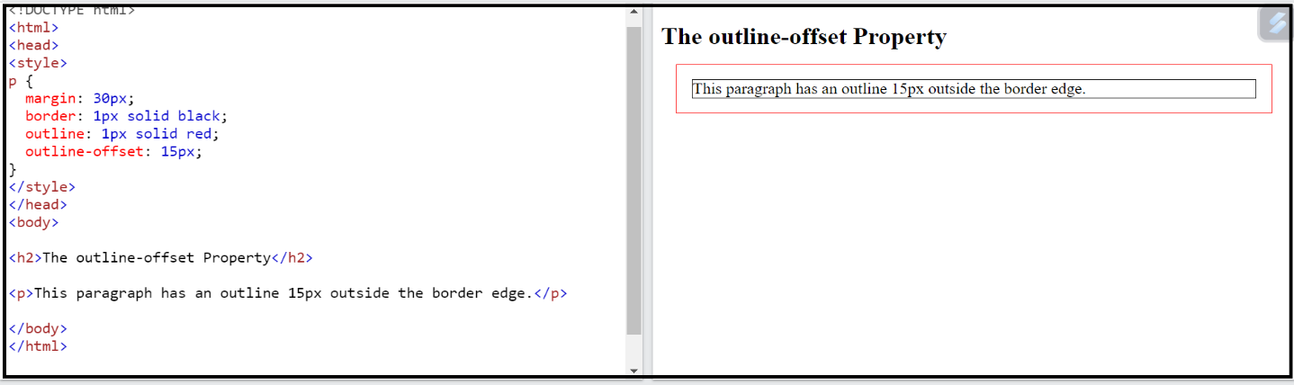

CSS has the following outline properties:

* borderline-style
* borderline-color
* borderline-width
* borderline-Sides

**CSS Borderline Style:-**

**Ex.**

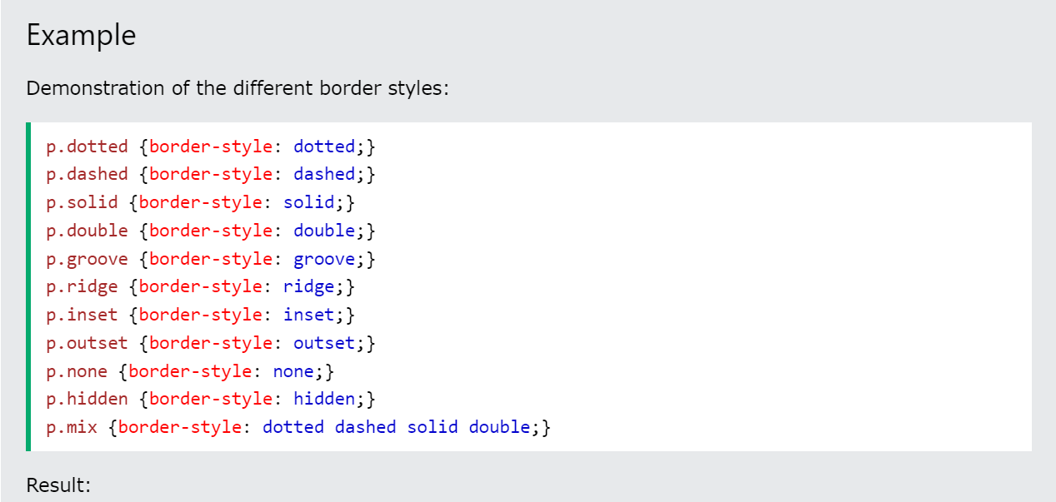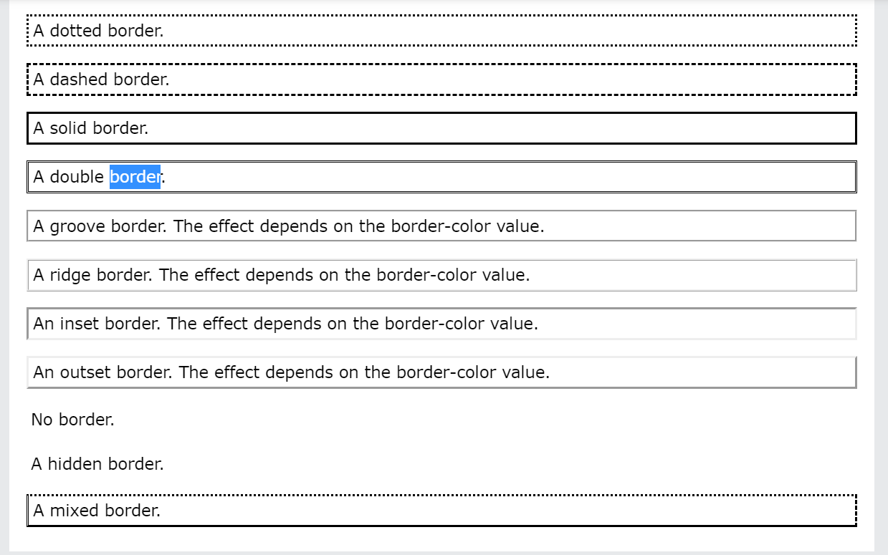

**CSS Border - Individual Sides**

**Ex.**

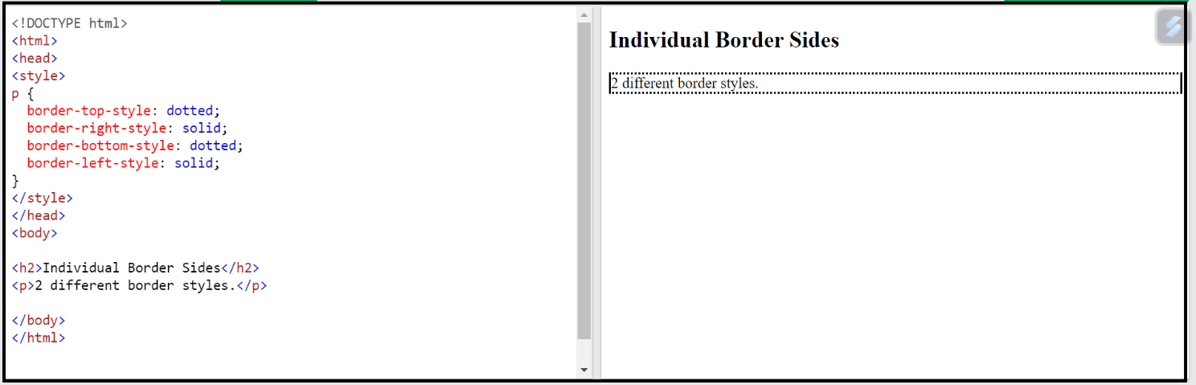

**CSS Border - Shorthand Property.**

**Ex.**

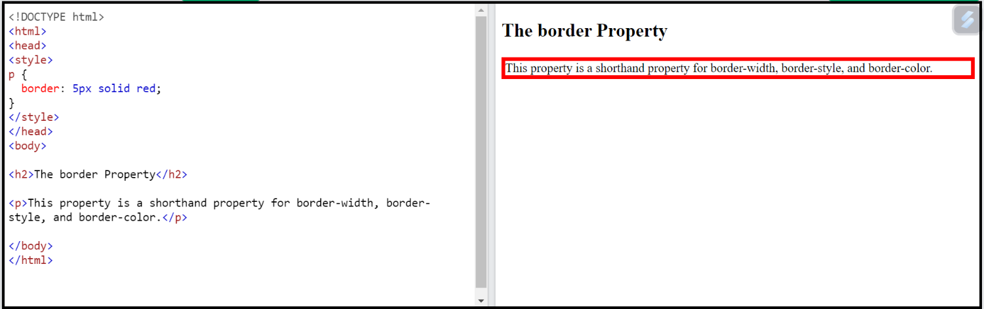

**BorderVsOutline.**

(Border line jage rokati hai Outline jage nahi rokati)